Moncton
2023
XVIIth Translation Games XVII^{es} Jeux de la traduction

Participation Guide
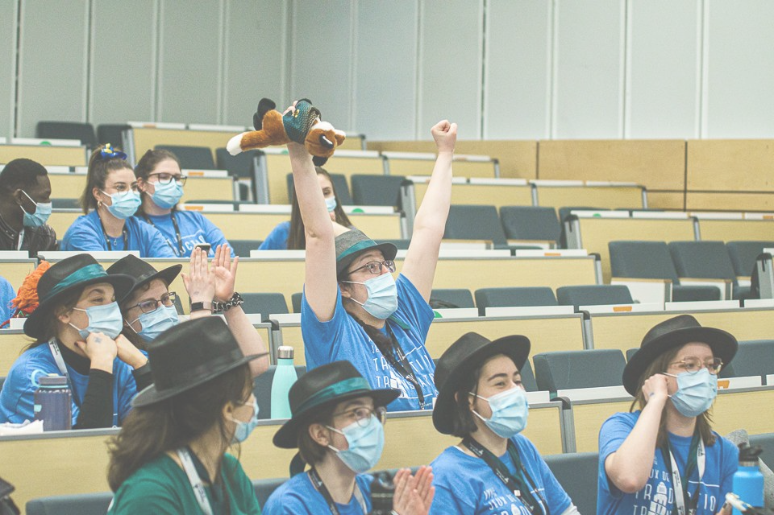
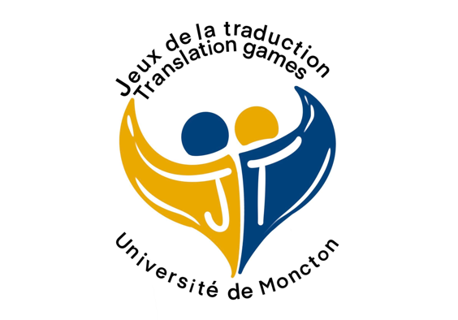
Contents
Message from the Organizing Committee 4
COVID-19 information 6
1. Certification 6
2. Face masks and hand sanitizing 6
3. Université de Montréal’s Info COVID-19 page 6
General information 7
1. Hotel 7
2. Rooms 7
3. Parking 7
4. Transportation 7
5. Discord server 8
Information about the Games 10
1. T-shirt and name tag 10
2. Roles 10
3. Mascots and other distinctive clothing elements 11
4. Gossip Box 11
5. Reference documents and intellectual honesty 11
6. Respect 11
Activities 12
Events 14
Awards 15
Schedule 16

Pictures: Jacques Bovin

Thank you to our platinum sponsor

thank you to our official partner
Département de linguistique et de traduction
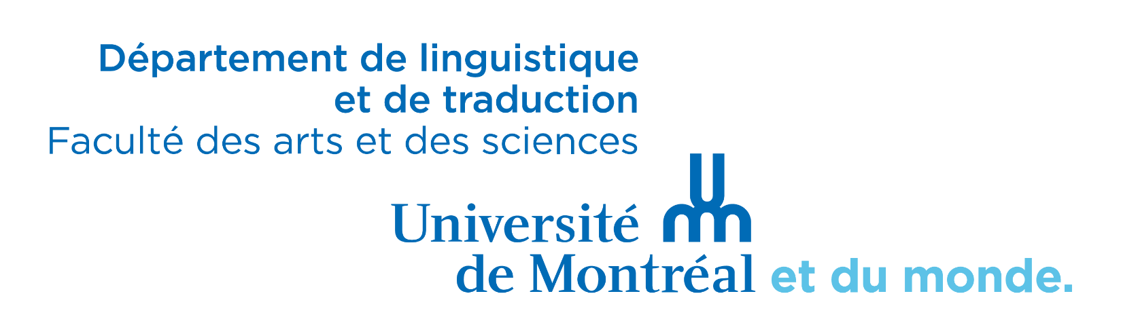
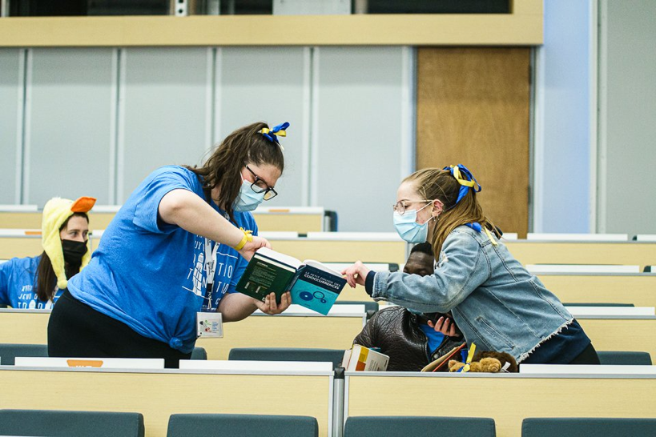
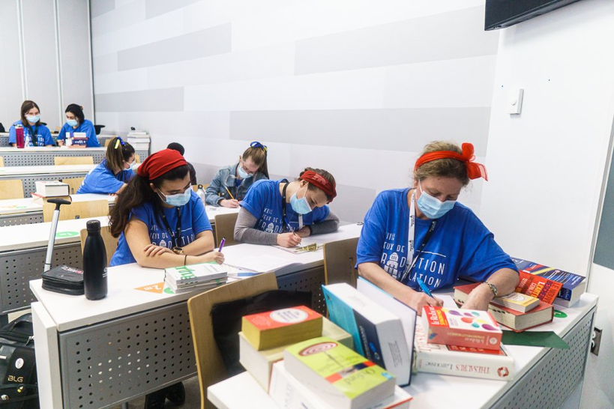

participating universities

Concordia University • Université Laval
McGill University • Université de Moncton
Université de Montréal • Université de Sherbrooke

Message du Comité organisateur

Message
 | Photo
Maude Durette  506-253-1715 | Stacy Bossé  #téléphone
Photo
Solène Bernard  #téléphone | Jean-Sébastien Landry  506-878-8138

If you’re lost or need help during the weekend, call one of the Committee members!

Thank you to our platinum sponsor

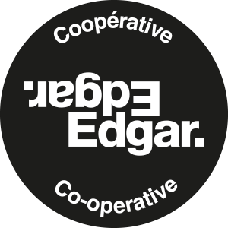

COVID-19 information

Certification
Since most of the health measures have been lifted in the last few months, you will not need proof of vaccination, nor a mask. However, we ask that you do not present yourself at l’Université de Moncton if you have any symptoms of Covid-19, as there are still some restrictions at the university.
That being said, it is very important to respect the measures in place. See the Info COVID-19 page of l’Université de Moncton for more information.

Face masks and hand sanitizing
Face masks are no longer mandatory at l’Université de Moncton, but they are recommended. If you feel more comfortable wearing one, please do so. It is important to respect each other’s boundaries and feelings. The classrooms are at half-capacity in an effort to prevent the spreading of Covid, need be.

Info COVID-19 - Université de Moncton
Please check out the university’s website, Info COVID-19 - Université de Moncton (in French only) prior to your arrival. We recommend familiarizing yourself with the information mentioned on that page before Saturday, April 1st, 2023. Anyone who does not respect the restrictions will have to leave the university.

Thank you to our gold sponsor
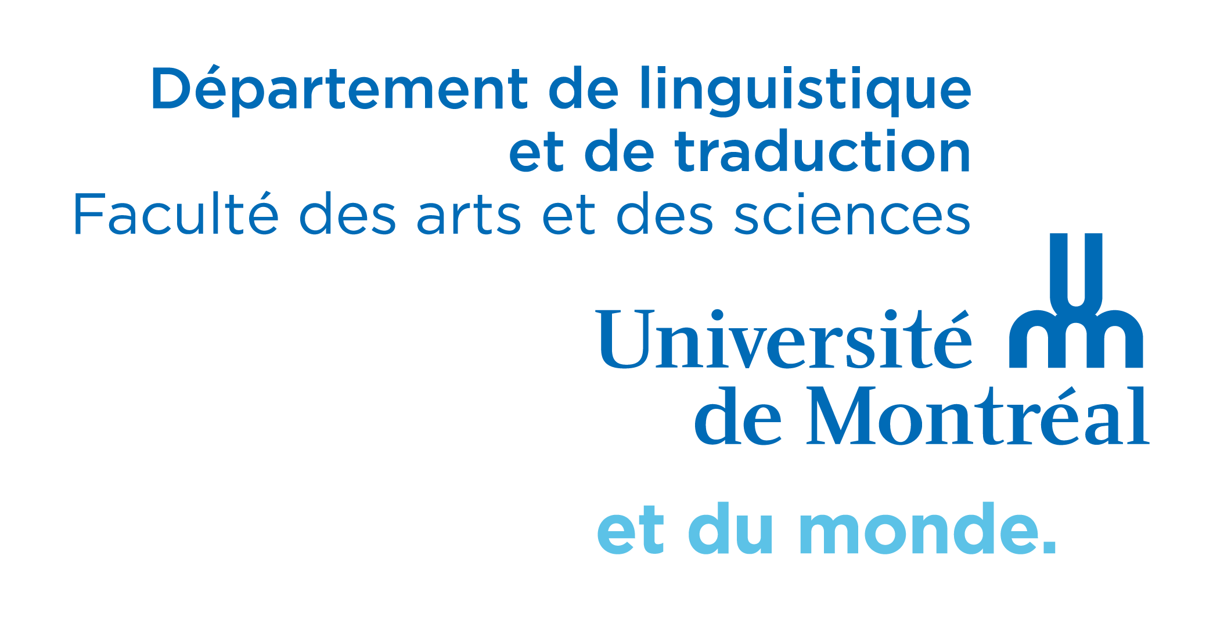
Faculté des arts et des sciences

General information

Hotel
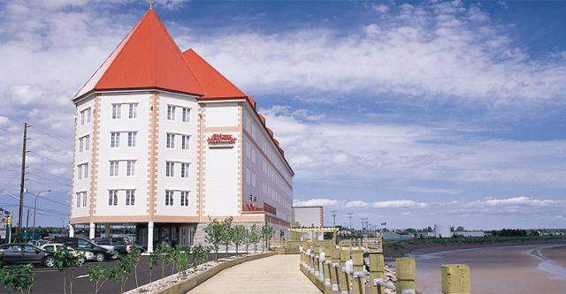
You will stay at the Chateau de Moncton hotel, which is, according to the website, conveniently located on Main Street. Most of our activities on Saturday will be on Main Street at walking distance.
The bus should arrive around 3 pm. When you arrive, you will have time to drop off your luggage in your room and get all dolled up for the networking cocktail taking place at Musée Resurgo starting at 5 p.m., followed at 6:30 p.m. by the Opening Banquet.
Address of Resurgo: 20 Mountain Street, Moncton (NB), E1C 2J8

Rooms
Like every year at the Translation Games, competitors, volunteers and hasbeens are divided in rooms of four people. However, this year, to accommodate everyone (you folks, and the committee), we decided that each of you can decide with whom you want to sleep. Two rooms have been reserved for each university. We suggest that you stay in pairs. Some of you might have to share a room with participants from other universities.
The first occupant of a room to arrive at the hotel will pick up all four keys for their room and will have to leave their credit card details at the front desk. That person is responsible for distributing the other keys to their roommates.
Note: Make sure not to start a movie on your room’s TV, or take any snacks or drinks served in the room, since the credit card associated with your room will get charged.
The check out is at 11 am. Be sure to be ready by then: if you are not, there will be a penalty rate charged to you.

Parking
The parking is included in the rate, so no need to worry about that!

Transportation
This year, we have been very lucky! We will be traveling with our own private bus from the Fleur de Lys compagny!
We will be travelling between the hotel and the university by bus on Saturday and Sunday. The events will be taking place in rooms located at the (...) buildings (3200 Jean-Brillant Street).
During Saturday evening, since the hotel is close to every restaurant and bar downtown, we will be walking.
A member of the Organizing Committee should always be with you during transportation. But since everybody gets lost sometimes, you’ll find a map of the area below.
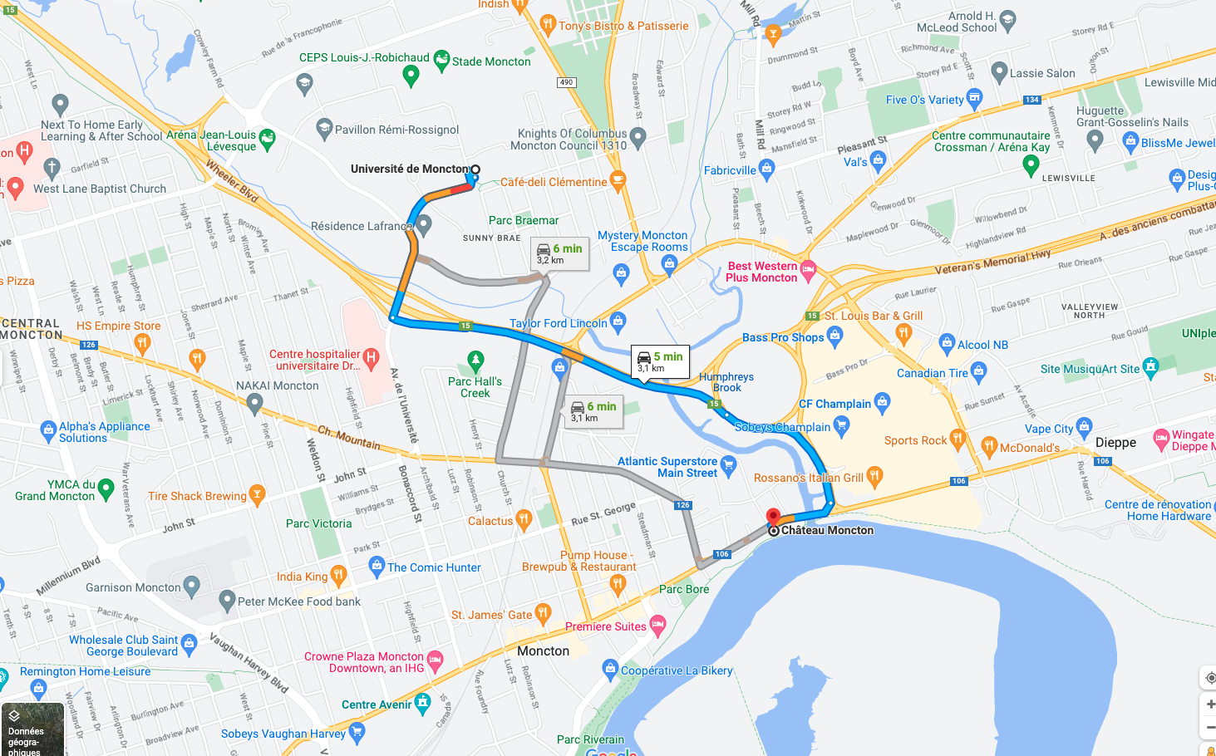

Discord server
Inspired (or scarred) by the lockdown, this year’s organizing committee has set up a private server on the digital communication platform Discord, adding a virtual dimension to the Translation Games.
Using the Games’ official server, you’ll be able to chat with other participants or members of your team while staying updated on ongoing events and key moments.
Even the famous Gossip Box found its way in a digital form on Discord, automated anonymity ensured by Tradigrade’s virtual alter ego!
Stay connected throughout the weekend: download the Discord app on your phone and click on the server invite link below to join the fun!
*Make sure to verify your email address to get access to the server.

It’s over here!
https://discord.gg/6RXp9MUfkD

Thank you to our silver sponsors

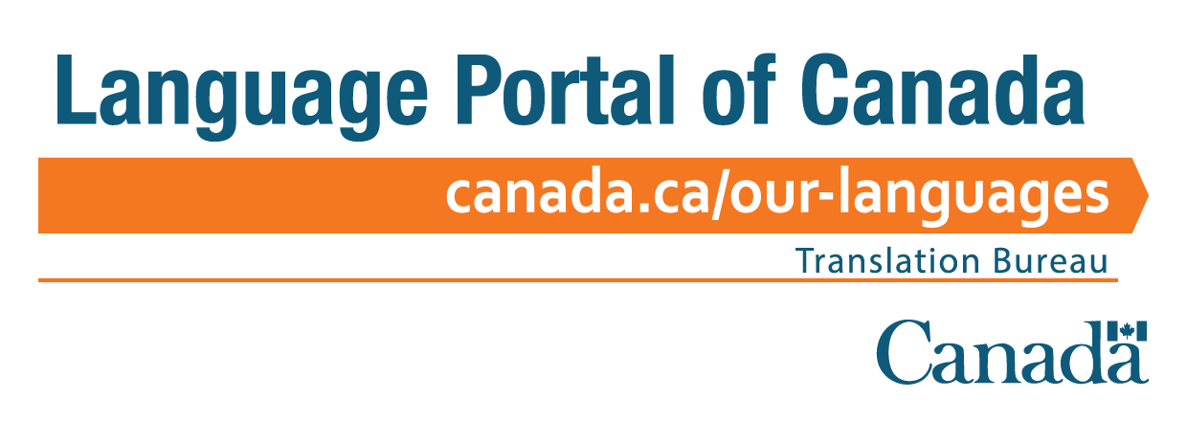

Information about the Games

T-shirt and name tag
The Translation Games official t-shirt must be worn during each event. Participants are asked to wear their name tags throughout the Games’ weekend.

Roles
Competitors
You are the protagonists. Making your entrance (or a comeback) into the world of the Games, you will be bravely facing the unknown, challenge after challenge. To this end, however, you will also be waking up early all weekend and still have to make sense the whole time.
Team captains
You are responsible for your own team. You ensure your teammates and other team-related personnel (volunteer and corrector) behave appropriately.
Volunteers
You are the supporting characters, the (presumably) quiet force to which we owe the Games’ smooth sailing. You will be helping the participants and Committee members throughout the weekend, be it by fetching water, acetaminophen and pens, or by helping with the lunches, prizes and coffee, etc.
Local volunteers
Think volunteers, but with home-field advantage.
Hasbeens
You had your 15 minutes of fame at one or several editions of the Games. You are present at the competition and partake in social activities. You may be called upon to help. Your presence keeps the Games tradition alive. Although some might consider you as fallen old-timers, you play a key role: awarding the Gerry.
Correctors
You are the real MVPs. You get up earlier than the competitors and will work more than them. Your reward: the satisfaction of having made the Games possible. Know that we hold you in great respect.
Mascots
No team is complete without its mascot! Mirroring your team, you are its true spearhead. As a little McGuffin, you will be jealously guarded all weekend from mischievous thieves. Stay on your toes!

Mascots and other distinctive clothing elements
Teams bring along a mascot to represent their university and wear distinctive clothing elements to stand out. This practice is strongly encouraged. According to tradition, teams sometimes take advantage of distracted teams to steal their mascots and keep them as a trophy.
This game must always remain playful and stay within certain limits. Mascot theft is forbidden during lectures and challenges. It is not allowed to attach your mascot to yourself, steal mascots in a way that could cause damage or demand a ransom to give it back. Any stolen mascot must be given back to its team by the end of that same night.

Gossip Box
Filled with gossip, hearsay, outrageous revelations and subtle (and not-so-subtle) comments on the Games and their participants, the Gossip Box never fails to surprise and bring out the laughs. Throughout the weekend, members of the Organizing Committee will read aloud your best rumours.

Reference documents and intellectual honesty
Only monolingual reference documents are allowed (English and French language dictionaries), as well as reference documents (grammar books and writing guides). Bilingual reference documents are forbidden (Grand Robert & Collins, Guide français-anglais de la traduction, etc.). Specialized monolingual reference documents (thesauri, and rhymes and collocation dictionaries) are allowed and can be useful for some of the challenges.
In these highly technological times, we remind you that it is strictly forbidden to use a cell phone during an event.

Respect
Participants must treat others with dignity, and respect is mandatory at all times. Behaviour and attitudes must promote and maintain the Translation Games’ good reputation.
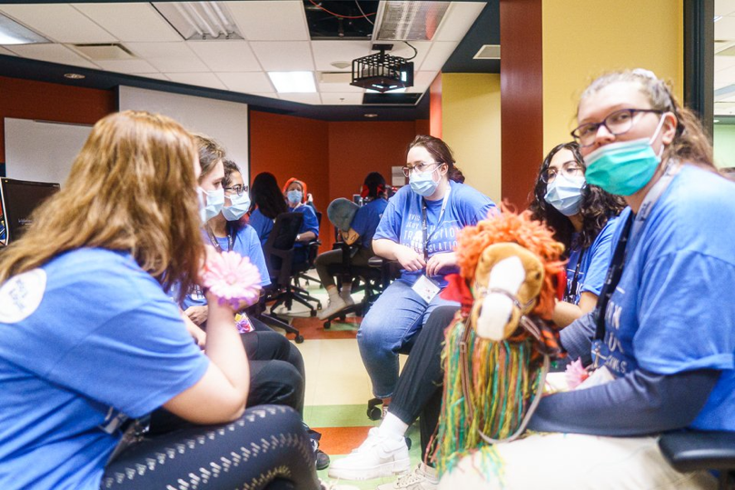
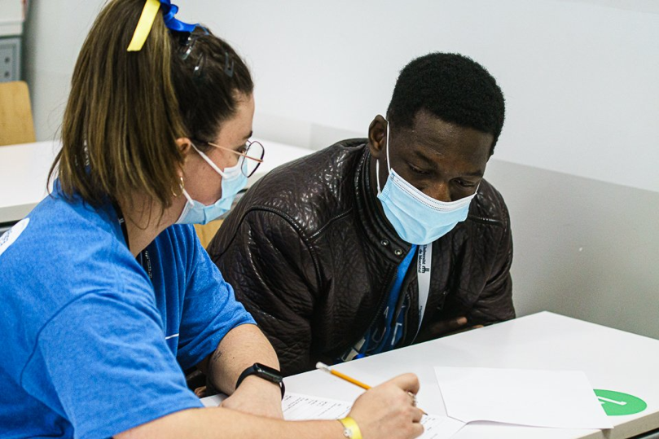

Activities

Networking Cocktail friday, 4 P.M. – 6:30 p.m.
Maisonneuve Hall
Semi-formal attire preferred
The Translation Games are also great for networking! Come meet the other teams, as well as the Committee and many of our generous sponsors. Besides, this may whet your appetite for the next event…

Opening Banquet friday, 6:30 p.m. – 9 p.m.
Dorchester, Atwater and St-Mathieu Halls
Decorum preferred
The traditional opening banquet. We simply cannot do without it. Besides, this is when teams do their introductory skits.
Their what? If any among you didn’t already know, each team must present a short skit (or song) to introduce themselves. As long as your presentation relates to the Games or to translation in some way, choose any form you like. Whatever you do, however, please keep it under five minutes. Don’t worry too much about it, though: if you go over the time limit, we’ll let you know…
As tradition dictates, the hosting university goes first. As for the others, the order of presentation was randomly generated as follows:
- Université de Montréal | - Université de Sherbrooke
- Concordia University | - McGill University
- Université de Moncton | - Université Laval

karaoke night friday, 9:30 p.m. to the end of the night
Taverne La Chic Régal 2567 Centre Street
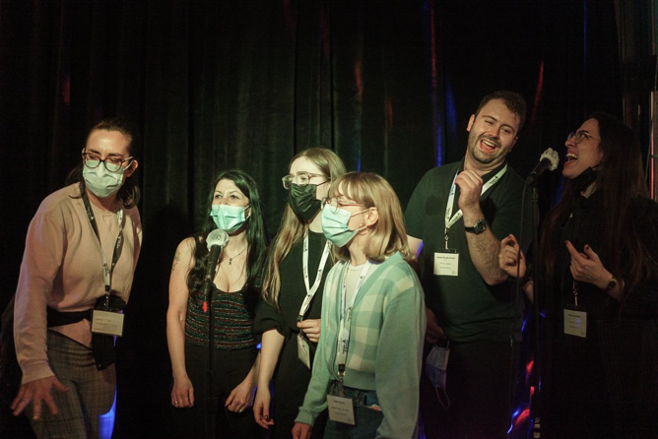
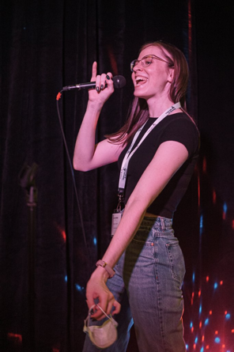
The banquet is over, but the night is only beginning. Come break the ice at the now-traditional karaoke night. Don’t be afraid of looking a bit foolish, you’re surrounded by friends after all. Take the opportunity to let your team stand out and get to know your fellow participants by singing your favourite songs.

Dining out saturday, 6:30 p.m. – 8:30 p.m.
Seoul Chako 1824 Sainte-Catherine Street West
Saturday night, we feast! We make our way to Seoul Chako, where a delectable Korean barbecue awaits. Heads up for the hungry among you: it’s all you can eat… (There will be vegetarian and vegan options.)

Night out saturday, 9 p.m. to the end of the night
Ye Olde Orchard Pub And Grill 1189 De la Montagne Street
After dinner, come have a drink (or two) get better acquainted and steal other teams’ mascots at Ye Olde Orchard Pub.

Learning Activities

5th Symposium on translation teaching friday, 1 p.m. – 3 p.m.
Room LB-612, LB Building, Concordia University 1400 De Maisonneuve Boulevard West
Évaluations, inclusivité et éthique, by Valérie Florentin (in French only)
As our classes get ever more diverse and as neuronal translation becomes a major issue, it is sometimes difficult to know what we are evaluating and what is the fairest way to evaluate something. This symposium will provide a place to discuss our most common issues and will give us the opportunity to bring up some plausible and proven solutions.
Intended for the correctors, this activity will be preceded with a lunch at noon (lunch box) courtesy of Université de Montréal’s Département de linguistique et de traduction.

Lecture saturday, 11 a.m. – 12 p.m.
Traduction, création et créativité, by Thomas O. St-Pierre (in French only)
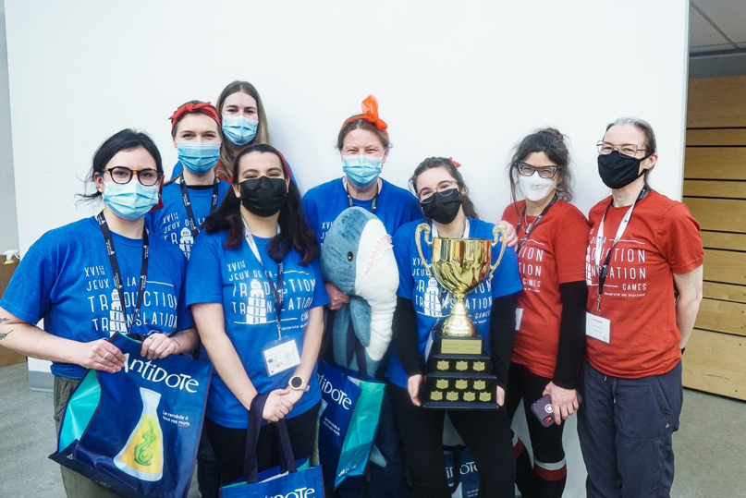
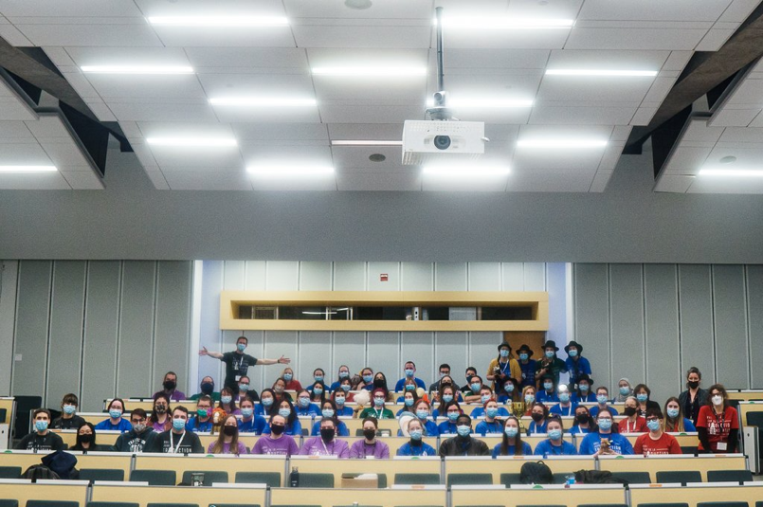
Where do the worlds of translation and creation (e.g., literary creation) intersect? Do you need to be creative to be a translator? How can translation feed literary creation? Where can you find the time to write for yourself when you have to translate 2,000 words a day? Those are some of the questions we will try to answer during this lecture!

Wi-Fi on campus: “UdeM non securise” network (Click here to learn how to connect [in French only])

Events

Individual Translation event (unilingual) 90 minutes
Brought to you by Edgar Co-op
This is the only individual event of the weekend. It’s time to shine through with your words and stand out from your fellow competitors. Pens at the ready!
Note: Each team member may translate into the language of their choice, but the team must participate in both linguistic combinations.

Song translation event (bilingual, teams of three) 90 minutes
You’ve got a great sense of rhythm? You have a gift for expressing the most complex of emotions in a handful of syllables? This event was made for you. But remember: there’s more to it than lyrics…

Audiovisual translation event (bilingual, teams of three) 90 minutes
Brought to you by RWS
Have you ever complained about the subtitling on a Netflix show? You’re pros, right? Give it a try.

comic book translation event (bilingual, teams of two) 75 minutes
The comic book translation event and its space limitations will demand originality and concision. Make sure you don’t go over the bubbles!

urban poetry translation event (bilingual, teams of two) – new! 75 minutes
For the first time at the Translation Games. The urban poetry translation event may remind you of song translation, but beware: the difficulties are completely different.

advertising event (bilingual, teams of two) 75 minutes
Brought to you by par OXO Innovation
The perfect event for transcreation aficionados: more than anything, you’ll need creativity and an affinity for puns to win this one.

Localization (bilingual, full team) – new! 120 minutes
Sunday’s event is known to be the wild card of the weekend. This year’s culminating event: the first ever Video Game Localization challenge! Competitors will pit the wits of their entire team one against the other in this ruthless task.

Awards

Individual translation champions
The writers of the best individual translations in French and English will be crowned Champions of the Games.

Translation games cup
The Translation Games Cup is awarded to the team with the highest score. (It’s had a makeover this year, to keep partying for a few more decades.)

Gerry-Boulet award
The Gerry-Boulet Award, AKA the Gerry, is one of the oldest Translation Games traditions. It is awarded to the team that best embodied the spirit of the Games over the weekend. The Gerry is awarded by the hasbeens based on the following criteria: participation in social activities, quality of the distinctive clothing elements, skit quality, interaction with other teams, participation to the Gossip Box and respect for the Translation Games traditions. Be ready to sing the Games’ anthem, adding your own verse to honour your university.

Aujourd’hui je vois la vie
Avec les yeux du traducteur
J’suis plus sensible aux anglicismes
Aux mots qui viennent de l’extérieur
Aujourd’hui je vois la vie
Avec les yeux du traducteur
Du traducteur...

Thank you to our bronze sponsors

Schedule – Friday, April 1st
 | Competitors | Hasbeens | Correctors
12:00 p.m. |  |  | Lunch, courtesy of the Département de linguistique et de traduction | 12:00 p.m.
12:15 p.m. |  |  |  | 12:15 p.m.
12:30 p.m. |  |  |  | 12:30 p.m.
12:45 p.m. |  |  |  | 12:45 p.m.
1:00 p.m. |  |  | Symposium | 1:00 p.m.
1:15 p.m. |  |  |  | 1:15 p.m.
1:30 p.m. |  |  |  | 1:30 p.m.
1:45 p.m. |  |  |  | 1:45 p.m.
2:00 p.m. |  |  |  | 2:00 p.m.
2:15 p.m. |  |  |  | 2:15 p.m.
2:30 p.m. |  |  |  | 2:30 p.m.
2:45 p.m. |  |  |  | 2:45 p.m.
3:00 p.m. | Hotel check-in and registration  Le Nouvel Hôtel et Spa  1740 René-Lévesque Boulevard West |  |  | 3:00 p.m.
3:15 p.m. |  |  |  | 3:15 p.m.
3:30 p.m. |  |  |  | 3:30 p.m.
3:45 p.m. |  |  |  | 3:45 p.m.
4:00 p.m. | Networking cocktail  Maisonneuve and Sherbrooke Halls |  |  | 4:00 p.m.
4:15 p.m. |  |  |  | 4:15 p.m.
4:30 p.m. |  |  |  | 4:30 p.m.
4:45 p.m. |  |  |  | 4:45 p.m.
5:00 p.m. |  |  |  | 5:00 p.m.
5:15 p.m. |  |  |  | 5:15 p.m.
5:30 p.m. |  |  |  | 5:30 p.m.
5:45 p.m. |  |  |  | 5:45 p.m.
6:00 p.m. |  |  |  | 6:00 p.m.
6:15 p.m. |  |  |  | 6:15 p.m.
6:30 p.m. | Opening banquet  Dorchester, Atwater and St-Mathieu Halls |  |  | 6:30 p.m.
6:45 p.m. |  |  |  | 6:45 p.m.
7:00 p.m. |  |  |  | 7:00 p.m.
7:15 p.m. |  |  |  | 7:15 p.m.
7:30 p.m. |  |  |  | 7:30 p.m.
7:45 p.m. |  |  |  | 7:45 p.m.
8:00 p.m. | Introductory skits  Dorchester, Atwater and St-Mathieu Halls |  |  | 8:00 p.m.
8:15 p.m. |  |  |  | 8:15 p.m.
8:30 p.m. |  |  |  | 8:30 p.m.
8:45 p.m. |  |  |  | 8:45 p.m.
9:00 p.m. | Travel by metro (20 min)  Guy-Concordia station to Charlevoix station |  |  | 9:00 p.m.
9:15 p.m. |  |  |  | 9:15 p.m.
9:30 p.m. | Karaoke  Taverne La Chic Régal  2567 Centre Street |  |  | 9:30 p.m.
9:45 p.m. |  |  |  | 9:45 p.m.
10:00 p.m. |  |  |  | 10:00 p.m.
To get back to the hotel: last metro at 12:38 a.m. (Charlevoix station, Honoré-Beaugrand direction), bus (350 at 1:50 and 2:37 a.m.) or 30 minutes by walk

Schedule – Saturday, April 2nd
 | Competitors | Hasbeens | Correctors
7:00 a.m. | Breakfast | Breakfast | Breakfast | 7:00 a.m.
7:15 a.m. |  |  |  | 7:15 a.m.
7:30 a.m. |  |  |  | 7:30 a.m.
7:45 a.m. |  |  |  | 7:45 a.m.
8:00 a.m. | Gathering in the main hall |  |  | 8:00 a.m.
8:15 a.m. | Shuttle to UdeM  (bus 165 and 166) |  |  | 8:15 a.m.
8:30 a.m. |  | Shuttle to UdeM  (bus 166 and 165) |  | 8:30 a.m.
8:45 a.m. |  |  |  | 8:45 a.m.
9:00 a.m. | Individual event  Literature  Jean-Brillant Building  (B-2325) | Board games  at UdeM  Jean-Brillant Building  (B-3255) | Shuttle to UdeM  (bus 165) | 9:00 a.m.
9:15 a.m. |  |  |  | 9:15 a.m.
9:30 a.m. |  |  | Chatting and bonding | 9:30 a.m.
9:45 a.m. |  |  |  | 9:45 a.m.
10:00 a.m. |  |  |  | 10:00 a.m.
10:15 a.m. |  |  |  | 10:15 a.m.
10:30 a.m. | Break with Edgar Co-op  (B-2325) |  | Receiving copies | 10:30 a.m.
10:45 a.m. |  |  | Correction  (undisclosed location) | 10:45 a.m.
11:00 a.m. | Lecture  (B-2325)  11:00 to 11:45 – Lecture  11:45 to 12:00 – Q&A |  |  | 11:00 a.m.
11:15 a.m. |  |  |  | 11:15 a.m.
11:30 a.m. |  |  |  | 11:30 a.m.
11:45 a.m. |  |  |  | 11:45 a.m.
12:00 p.m. | Lunch  Jean-Brillant Building  (B-2325) |  |  | 12:00 p.m.
12:15 p.m. |  |  |  | 12:15 p.m.
12:30 p.m. |  |  |  | 12:30 p.m.
12:45 p.m. |  |  |  | 12:45 p.m.
1:00 p.m. | Events in teams of three  Audiovisual  (B-3250)  Songs  (B-3265) | Heading to A/Maze by metro  (Côtes-des-Neiges to Atwater) | Correction  (undisclosed location)  Correction  (undisclosed location) | 1:00 p.m.
1:15 p.m. |  |  |  | 1:15 p.m.
1:30 p.m. |  | A/Maze  Outdoor Escape Game  3550 Saint-Jacques Street  A/Maze  Outdoor escape game  3550 Saint-Jacques Street |  | 1:30 p.m.
1:45 p.m. |  |  |  | 1:45 p.m.
2:00 p.m. |  |  |  | 2:00 p.m.
2:15 p.m. |  |  |  | 2:15 p.m.
2:30 p.m. | Break  (B-2325) |  |  | 2:30 p.m.
2:45 p.m. |  |  |  | 2:45 p.m.
3:00 p.m. | Events in teams of two  Advertising (B-3250)  Urban Poetry (B-3255)  Comics (B-3265) |  |  | 3:00 p.m.
3:15 p.m. |  |  |  | 3:15 p.m.
3:30 p.m. |  |  |  | 3:30 p.m.
3:45 p.m. |  |  |  | 3:45 p.m.
4:00 p.m. |  | Free Time  Ideal moment for  a mini-putt game  [Putting Edge Downtown] |  | 4:00 p.m.
4:15 p.m. | Back to the hotel by metro |  | Back to the hotel by metro | 4:15 p.m.
4:30 p.m. |  |  |  | 4:30 p.m.
4:45 p.m. |  |  |  | 4:45 p.m.
5:00 p.m. | Free time at the hotel  Gathering at 6:15 p.m. to head toward Seoul Chako |  |  | 5:00 p.m.
5:15 p.m. |  |  |  | 5:15 p.m.
5:30 p.m. |  |  |  | 5:30 p.m.
5:45 p.m. |  |  |  | 5:45 p.m.
6:00 p.m. |  |  |  | 6:00 p.m.
6:15 p.m. | Walking to Seoul Chako |  |  | 6:15 p.m.
6:30 p.m. | Dinner at Seoul Chako  1824 St. Catherine Street West |  |  | 6:30 p.m.
6:45 p.m. |  |  |  | 6:45 p.m.
7:00 p.m. |  |  |  | 7:00 p.m.
7:15 p.m. |  |  |  | 7:15 p.m.
7:30 p.m. |  |  |  | 7:30 p.m.
7:45 p.m. |  |  |  | 7:45 p.m.
8:00 p.m. |  |  |  | 8:00 p.m.
8:15 p.m. |  |  |  | 8:15 p.m.
8:30 p.m. | Evening at Ye Olde Orchard Pub And Grill  1189 De la Montagne Street |  |  | 8:30 p.m.
8:45 p.m. |  |  |  | 8:45 p.m.
9:00 p.m. |  |  |  | 9:00 p.m.
9:15 p.m. |  |  |  | 9:15 p.m.
9:30 p.m. |  |  |  | 9:30 p.m.
9:45 p.m. |  |  |  | 9:45 p.m.
10:00 p.m. |  |  |  | 10:00 p.m.
To get back to the hotel: 11-minutes walk

Schedule – Sunday, April 3rd
 | Competitors | Hasbeens | Correctors
7:00 a.m. | Breakfast and checkout | Breakfast and checkout | Breakfast and checkout | 7:00 a.m.
7:15 a.m. |  |  |  | 7:15 a.m.
7:30 a.m. |  |  |  | 7:30 a.m.
7:45 a.m. |  |  |  | 7:45 a.m.
8:00 a.m. |  |  | Shuttle to UdeM  (bus 165 at 8:07 a.m.) | 8:00 a.m.
8:15 a.m. |  |  |  | 8:15 a.m.
8:30 a.m. | Gathering in the main hall | Gerry deliberations | Correction  (undisclosed location) | 8:30 a.m.
8:45 a.m. | Shuttle to UdeM  (bus 165 and 166) |  |  | 8:45 a.m.
9:00 a.m. |  | Downtown Touring with  Kaléidoscope Tours |  | 9:00 a.m.
9:15 a.m. |  |  |  | 9:15 a.m.
9:30 a.m. | Team event  Video Game Localisation  Samuel-Bronfman Building  (BLSH) |  |  | 9:30 a.m.
9:45 a.m. |  |  |  | 9:45 a.m.
10:00 a.m. |  |  |  | 10:00 a.m.
10:15 a.m. |  |  |  | 10:15 a.m.
10:30 a.m. |  |  |  | 10:30 a.m.
10:45 a.m. |  |  |  | 10:45 a.m.
11:00 a.m. |  | Shuttle to UdeM |  | 11:00 a.m.
11:15 a.m. |  |  |  | 11:15 a.m.
11:30 a.m. | Lunch  Jean-Brillant Building  (B-2325) |  |  | 11:30 a.m.
11:45 a.m. |  |  |  | 11:45 a.m.
12:00 p.m. |  |  |  | 12:00 p.m.
12:15 p.m. |  |  |  | 12:15 p.m.
12:30 p.m. | Quiz and activities with Oktocom  Jean-Brillant Building  (B-2325) |  | Correction  (undisclosed location) | 12:30 p.m.
12:45 p.m. |  |  |  | 12:45 p.m.
1:00 p.m. |  |  |  | 1:00 p.m.
1:15 p.m. |  |  |  | 1:15 p.m.
1:30 p.m. |  |  |  | 1:30 p.m.
1:45 p.m. |  |  |  | 1:45 p.m.
2:00 p.m. | Coffee-Selfie-Nappie Time  UdeM campus tour (optional) |  |  | 2:00 p.m.
2:15 p.m. |  |  |  | 2:15 p.m.
2:30 p.m. | Closing ceremony  Jean-Brillant Building  (B-2325) |  |  | 2:30 p.m.
2:45 p.m. |  |  |  | 2:45 p.m.
3:00 p.m. |  |  |  | 3:00 p.m.
3:15 p.m. |  |  |  | 3:15 p.m.
3:30 p.m. |  |  |  | 3:30 p.m.
3:45 p.m. | Group picture |  |  | 3:45 p.m.
4:00 p.m. | Departure |  |  | 4:00 p.m.
4:15 p.m. |  |  |  | 4:15 p.m.

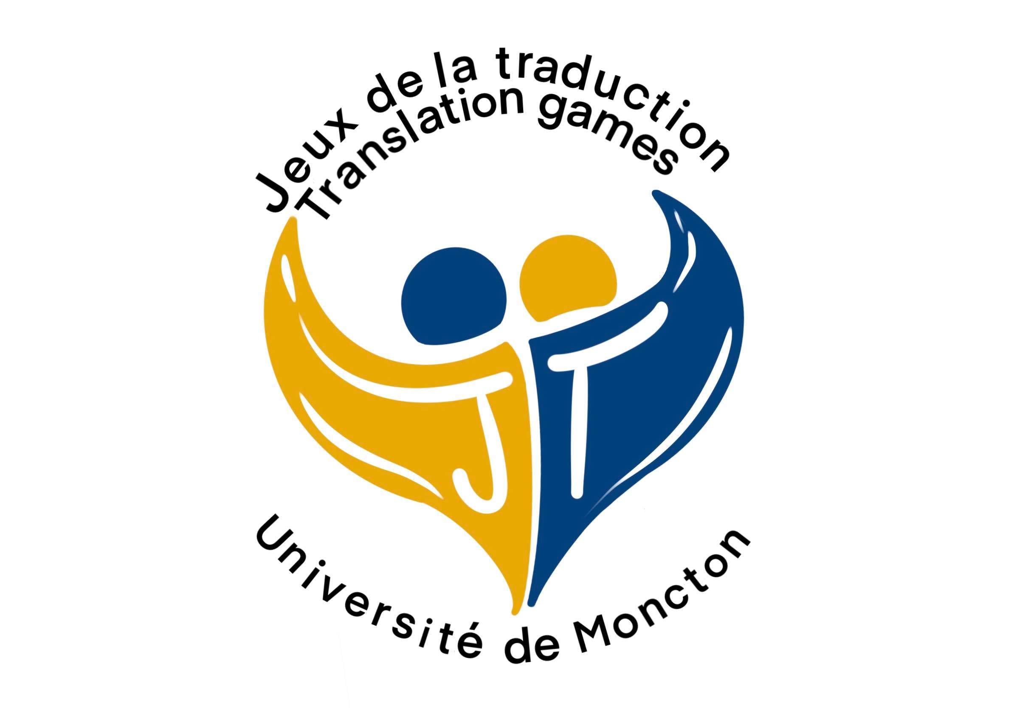

Le comité organisateur des XVII^{es} Jeux de la traduction
The XVIIth Translation Games Organizing Committee
comite.jeuxdelatraduction@gmail.com | jeuxdelatraduction.ca | translationgames.ca
https://www.facebook.com/jeuxdelatraduction

